DESIGN REVIEW AND MAINTENANCE GUIDELINES

AUDUBON SQUARE/FALLBROOK HOMEOWNER’S ASSOCIATION
(AUDUBON SQUARE)
Adopted: August 1986; Revised: _______ 20__

WHEREAS, the Design Review and Maintenance Guidelines (“Guidelines”) were adopted for Owners’ convenience to clarify the architectural requirements, guidelines and standards within the community;

WHEREAS, additional styles of sheds and house plaques have been considered in an effort to expand the types of approved styles available for Owners, while preserving the community’s cohesive look;

WHEREAS, there is a need to update and amend the Guidelines to further define, clarify, and expand the architectural rules and regulations of sheds and house plaques;

WHEREAS, Owners must still complete and submit an Application for Architectural Change to the Architectural Environmental Control Committee before making any changes to their Lots and/or dwelling units;

NOW THEREFORE, the following additions have been made to the Guidelines regarding sheds and house plaques, and are effective immediately:

- Approved Shed Designs: 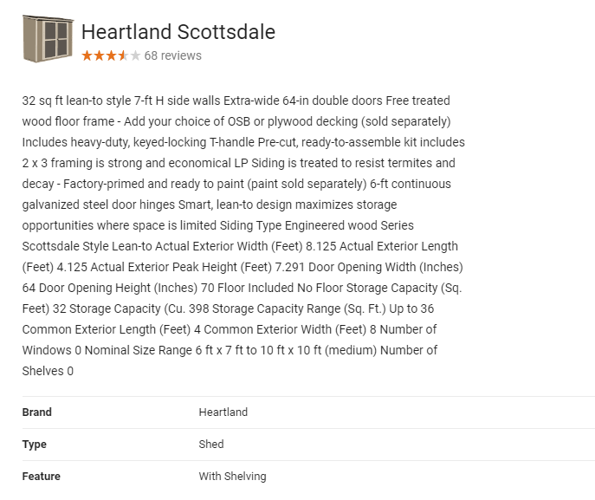

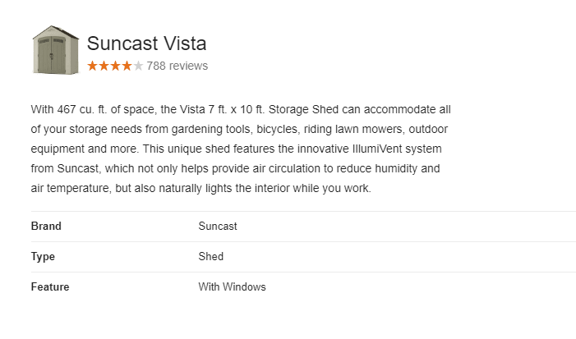

- House Plaque Requirements:

In an emergency, police, fire and rescue workers depend on house numbers to find YOU as quickly as possible. Finding your home - especially at night - can be challenging if address numbers are unreadable, hidden, unlighted or have missing numbers and may delay emergency responders from getting to you as quickly as possible.
All house numbers and plaques must meet the following criteria:
- An AECC application must be submitted and approved before any house numbers are installed or replaced.
- House numbers must be visible from the street and displayed in a conspicuous place that is unobstructed and clearly readable from the street. House numbers may be placed on or beside the front door. If the front door is not easily seen from the street, the house numbers may be placed on a post, fence or tree at the driveway entrance so they can be clearly seen from the street. In addition to house numbers on the front door of the house, if you have a rural-style mailbox, reflective and contrasting numbers should be placed on both sides of the box so they can be seen by an emergency vehicle approaching from either direction.
- Existing residential house numbers may be 3 1/2 inches high. However, all new or replaced residential house numbers must be at least 5 inches high.
- House numbers must be placed on a contrasting background, with a reflective coating on the numbers for easy visibility at night.
- Owners must repair and/or replace aging house number plaques, especially on mailboxes that are a distance from the front of the residence.
- Owners must prune any bushes, tree limbs or other growth that has covered their house numbers to ensure their visibility.
- Where a structure has more than one (1) address or where more than one (1) structure shares a common entry or driveway, house numbers must designate the addresses in sequence.
- The following and other similar types of house number plaques are acceptable:
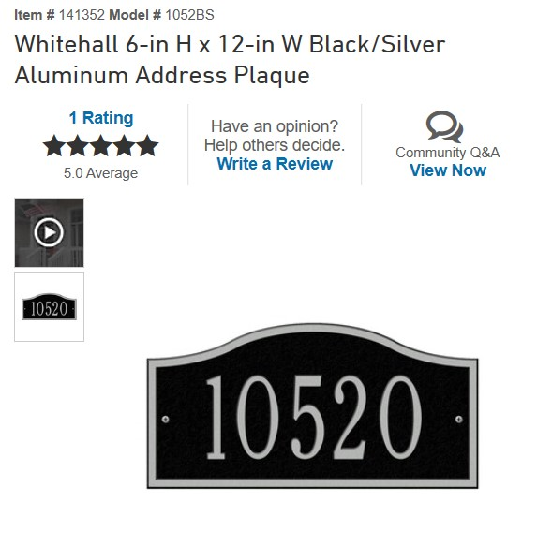
(https://www.lowes.com/pd/Whitehall-6-in-H-x-12-in-W-Black-Silver-Aluminum-Address-Plaque/50201077)

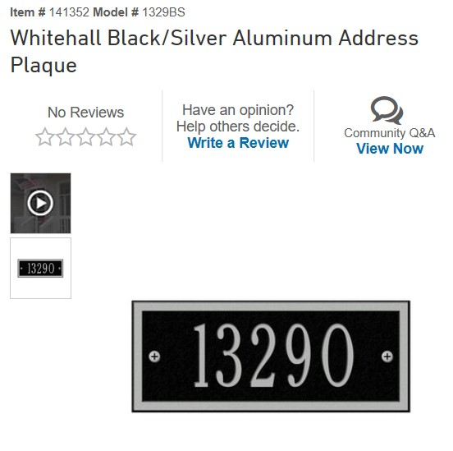
(https://www.lowes.com/pd/Whitehall-Black-Silver-Aluminum-Address-Plaque/50078618)

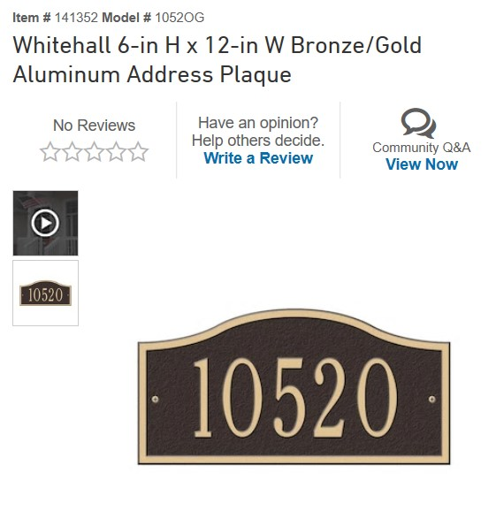
(https://www.lowes.com/pd/Whitehall-6-in-H-x-12-in-W-Bronze-Gold-Aluminum-Address-Plaque/50201081)

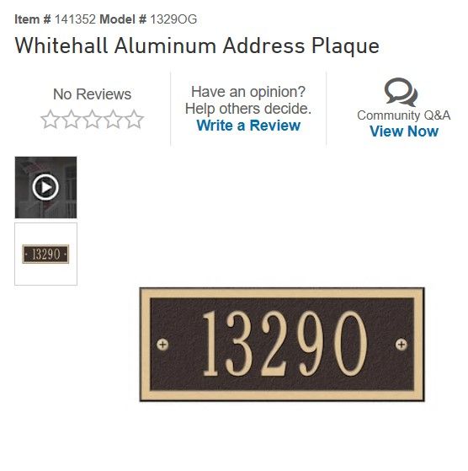
(https://www.lowes.com/pd/Whitehall-Aluminum-Address-Plaque/50078622)

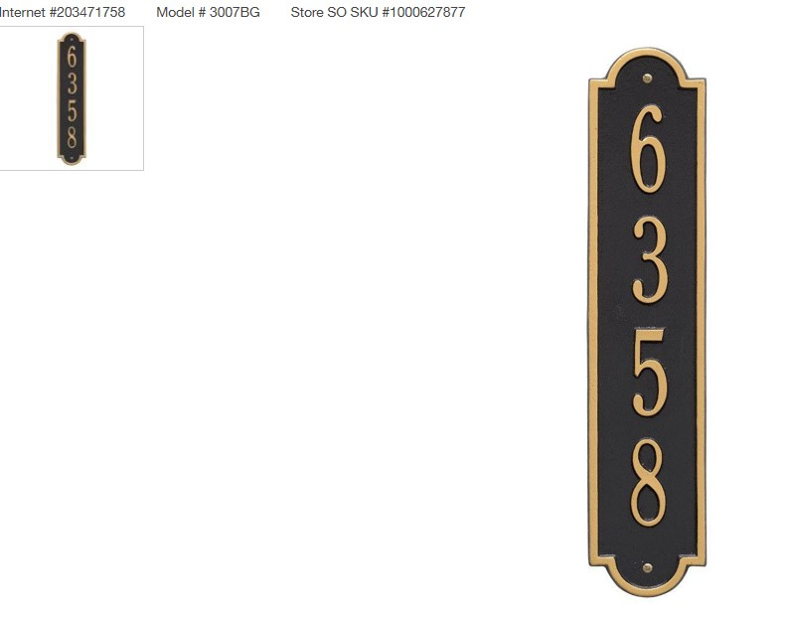
(1-Line-Vertical-Address-Plaque-3007BG/203471758)

